DIRECT SELLER AGREEMENT

This Agreement ("Agreement") is made on this ___ day of _______, 20, by and between:
Liora Crest LLP company incorporated under the Companies Act, 2013, having its registered office at 3/11, Thenguvila Puthen Veedu, Cheriyela, Alummoodu (po) Kollam - 691577, (hereinafter referred to as the “Company” or “Direct Selling Entity”),
AND I ____________, residing at __________________________________________
________________________________________________________________ , holding
Aadhaar/PAN No. _____________, (hereinafter referred to as the “Direct Seller”).
Collectively referred to as the "Parties" and individually as a "Party".

1. Purpose
This Agreement is entered into pursuant to Rule 6(1)(a) of the Consumer Protection (Direct Selling) Rules, 2021, and outlines the terms and conditions under which the Direct Seller is authorized to promote and sell the products/services of the Company.

2. Appointment
The Company hereby appoints the Direct Seller, and the Direct Seller accepts the appointment, as a non-exclusive independent contractor to promote, market, and sell the Company’s products/services.3. Term
This Agreement shall commence on the date first above written and shall remain valid unless terminated earlier in accordance with the terms of this Agreement.

4. Eligibility Criteria
The Direct Seller represents and warrants that:
- They are at least 18 years old.
- They are legally competent to enter into a binding agreement.
- They are not an employee of the Company.
- They have not been convicted of any criminal offense.

5. Duties and Obligations of the Direct Seller
The Direct Seller agrees to:
- Act in a lawful, ethical, and professional manner.
- Not make any false or misleading claims about the Company or its products/services.
- Explain to prospective customers their rights under the Consumer Protection Act, 2019.
- Not induce customers to purchase products through misleading, deceptive, or unfair trade practices.
- Maintain proper records and documentation.
- Comply with all applicable laws, including those under the Consumer Protection Act, 2019, and Direct Selling Rules, 2021.

6. Commissions and Remuneration
The Direct Seller shall be entitled to earn commission/bonuses strictly based on actual sales of products/services in accordance with the compensation plan provided by the Company.
No commission shall be paid for recruitment of other Direct Sellers.

7. Prohibition of Pyramid Scheme
The Direct Seller shall not:
- Promote or participate in any pyramid scheme.
- Entroll others solely for the purpose of earning commission without actual sale of products.

8. Cooling-Off Period
The Direct Seller shall have the right to terminate this Agreement within 30 days from the date of execution without any penalty or obligation by giving written notice.

9. Buy-Back Policy
The Company shall provide a buy-back policy allowing return of currently marketable goods purchased within 30 days from the date of purchase as per the conditions stated in the policy.

10. Termination
This Agreement may be terminated:
- By either Party by giving 30 days’ written notice.
- By the Company without notice in case of any breach of terms or unlawful conduct by the Direct Seller.
Upon termination, the Direct Seller shall cease to represent the Company and return all company materials and documents.

11. Intellectual Property
All logos, trademarks, and marketing materials remain the sole property of the Company. The Direct Seller shall not use such materials for any purpose other than as authorized.

12. Relationship of the Parties
Nothing in this Agreement shall be construed to create an employer-employee relationship. The Direct Seller is an independent contractor and shall not represent themselves as an agent or employee of the Company.

13. Dispute Resolution
Any dispute arising under this Agreement shall be resolved through mutual negotiation. If unresolved, the matter shall be referred to arbitration in accordance with the Arbitration and Conciliation Act,1996. Jurisdiction shall be with the courts at Kollam district Kerala,India only.

14. Miscellaneous
- This Agreement constitutes the entire understanding between the Parties.
- No amendment shall be valid unless in writing and signed by both Parties.
- This Agreement is governed by the laws of India.
- IN WITNESS WHEREOF
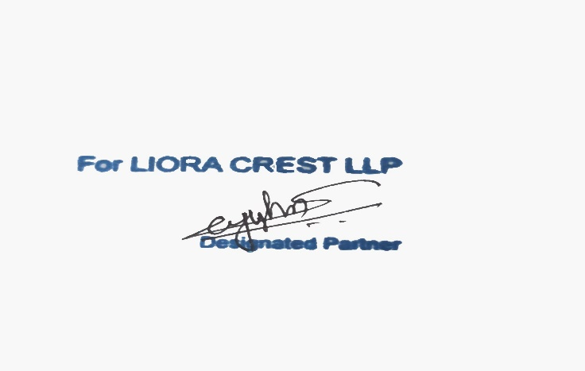
The Parties have executed this Agreement on the date and year first above written.



For the Company

Name: John Thariyan
Designation: Managing Partner
Date:

Direct Seller
(Signature)
Name:
Date:

